Annual Bonus Report

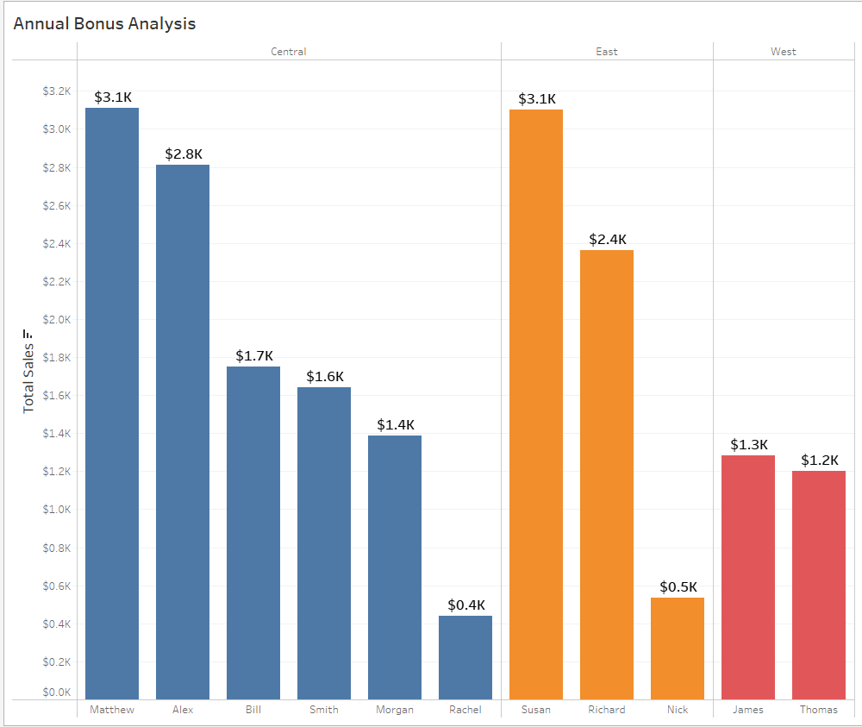

# This Quarter: Mathew from Central, Susan from East and James from West will be getting an Annual Bonus!